**Design Thinking Project Workbook**

**Don't find customers for your product but find products for your customers**

**1. Team**

**Team Name**: LoanGenius

**Team Logo (if any):**

**Team Members:**

1. K.Abhigna, Team Lead , 2320030089
2. K.Santhoshini , Team Member , 2320030304
3. M.S.Maha Lakshmi , Team Member , 2320030218

**2. Problem/Opportunity Domain**

**Domain of Interest:**

The domain of interest is **Finance and Artificial Intelligence (AI)**, specifically focusing on **Loan Eligibility Prediction**. This area combines financial analytics, risk assessment, and AI-driven predictive modeling to streamline loan approval processes and enhance decision-making accuracy for financial institutions.

**Description of the Domain:**

Loan eligibility prediction is a critical function in banking and financial services, involving the evaluation of an applicant’s financial history, income, creditworthiness, and other parameters. Traditional methods rely heavily on manual assessments and predefined rules, often leading to inefficiencies and human error. AI-powered systems can analyze large datasets, detect patterns, and provide accurate predictions for loan approval, reducing risk and improving service delivery.

**Why did you choose this domain?**

* High Impact – AI-driven automation improves accuracy and fairness in loan approvals.
* Market Potential – The fintech industry is rapidly growing, demanding intelligent solutions.
* Research Advancements – AI enables better insights into borrower behavior and risk profiling.
* Accessibility – Automated systems can offer faster decisions even in underbanked regions.

**3. Problem/Opportunity Statement**

**Problem Statement:**

Many financial institutions face challenges in accurately assessing loan eligibility due to outdated manual processes and limited access to real-time financial data. This leads to delays, loan defaults, and missed opportunities. AI-based models can improve prediction accuracy, reduce risk, and increase approval rates by analyzing diverse data points more efficiently.

**Problem Description:**

Loan processing traditionally involves reviewing documents, calculating ratios, and making subjective decisions, which can be biased or error-prone. Applicants with non-traditional financial backgrounds or those in remote areas often get overlooked. There's a need for a more inclusive, automated, and data-driven approach to assess loan eligibility reliably.

**Context (When does the problem occur):**

* During the initial loan application screening process.
* When applicants lack formal income proof but have alternative financial indicators.
* In underserved areas with limited access to banks and financial advisors.

**Alternatives (What does the customer do to fix the problem):**

* Manual Review – Loan officers manually evaluate income, credit score, and documents.
* Rule-Based Systems – Predefined thresholds for eligibility, often too rigid.
* Credit Scoring Agencies – Rely solely on credit history, excluding other factors.
* Third-Party Lending Apps – May lack deep verification, increasing fraud risk.

**Customers (Who has the problem most often):**

* Loan applicants with variable or informal incomes.
* Financial institutions aiming to reduce default rates and streamline processing.
* Fintech startups offering alternative lending solutions.
* Underbanked individuals seeking financial inclusion.

**Emotional Impact (How does the customer feel):**

* Applicants feel anxious and discouraged when rejected due to incomplete evaluation.
* Bank employees face pressure to process loans quickly with minimal error.
* Institutions fear financial loss due to inaccurate predictions or fraud.

**Quantifiable Impact (What is the measurable impact):**

* Up to 30% of eligible borrowers are rejected due to lack of proper documentation.
* Manual loan processing may take several days, reducing customer satisfaction.
* Default rates can reach 10% or more without accurate risk analysis.
* Automated systems can reduce processing time by 70% and improve prediction accuracy.

**Alternative Shortcomings (What are the disadvantages of the alternatives):**

* **Manual evaluation is slow and inconsistent** – Traditional loan approval relies heavily on human judgment, leading to delays and potential bias.
* **Lack of transparency** – Applicants often don’t understand why they were rejected, creating frustration and distrust in the system.
* **Limited accessibility** – Many individuals, especially in rural or informal sectors, struggle to access formal banking services or meet strict documentation requirements.

**Any Video or Images to showcase the problem:**

No specific videos or images are available at this time.

**4. Addressing SDGs**

**Relevant Sustainable Development Goals (SDGs):**

* + **SDG 1: No Poverty** – Reducing poverty through access to financial services.
  + **SDG 8: Decent Work and Economic Growth** – Promoting inclusive financial system economic empowerment.
  + **SDG 9: Industry, Innovation, and Infrastructure** – Using AI to modernize financial services and infrastructure.

**How does your problem/opportunity address these SDGs?:**

**SDG 1: No Poverty**

**➢ Improves access to loans for individuals with non-traditional income sources.**

**➢ Enables financially underserved populations to start businesses or improve livelihoods.**

**SDG 8: Decent Work and Economic Growth**

**➢ Supports economic activity by enabling small businesses and entrepreneurs to access capital.**

**➢ Encourages responsible lending through data-driven risk analysis, reducing loan defaults.**

**SDG 9: Industry, Innovation, and Infrastructure**

**➢ Applies AI and machine learning to automate and optimize loan approval systems.**

**➢ Drives innovation in fintech, improving efficiency, transparency, and inclusiveness in financial services.**

**5. Stakeholders**

1. **Who are the key stakeholders involved in or affected by this project?**

* Loan Applicants
* Bank Loan Officers & Financial Advisors
* Data Scientists & AI Developers
* Banks & Financial Institutions
* Fintech Startups
* Regulatory Authorities (e.g., central banks, financial watchdogs)

1. **What roles do the stakeholders play in the success of the innovation?**

* Loan Applicants: Provide application data, financial history, and feedback
* Bank Officers: Use and evaluate the AI system during loan processing
* Data Scientists: Design, train, and refine predictive models
* Banks: Deploy the solution, provide access to historical data, and ensure integration
* Fintechs: Innovate user interfaces and expand reach
* Regulators: Define compliance, ensure fairness, and approve data usage policies

1. **What are the main interests and concerns of each stakeholder?**

* Applicants: Fair, quick, and accurate loan decisions
* Bank Officers: Trustworthy tools that enhance productivity
* Data Scientists: Access to quality data, clear problem definition
* Banks: Cost-effective, scalable, and risk-reducing solutions
* Fintechs: Competitive advantage and user retention
* Regulators: Data protection, fairness, and transparency

1. **How much influence does each stakeholder have on the outcome of the project?**

* High: Banks, data scientists, fintech companies
* Medium: Loan applicants, bank officers
* Low: Regulatory bodies (but with significant indirect influence)

1. **What is the level of engagement or support expected from each stakeholder?**

* High: Banks, data science teams, fintech partners
* Medium: Loan applicants, financial advisors
* Low: Regulators (engaged mostly during compliance and approval stages)

1. **Are there any conflicts of interest between stakeholders? If so, how can they be addressed?**

* Bank officers may fear automation reducing their roles
* Concerns about fairness in AI decisions among regulators and applicants
* Address by:
* Positioning AI as a decision-support tool, not a replacement
* Implementing explainable AI (XAI) to ensure transparency
* Strict compliance with privacy laws and ethical AI standards

1. **How will you communicate and collaborate with stakeholders throughout the project?**

* Workshops and training sessions for bank staff
* User feedback from applicants through surveys and forms
* Agile sprint reviews and reports with data science and fintech teams
* Compliance briefings and documentation for regulatory bodies
* Use of collaboration tools (Slack, Jira, Zoom, etc.) for real-time updates

1. **What potential risks do stakeholders bring to the project, and how can these be mitigated?**

* Resistance to automation: Offer training and show efficiency benefits
* Bias in AI models: Ensure diverse and representative datasets
* Data privacy risks: Use encryption and anonymized data
* Regulatory roadblocks: Engage with regulators early and comply with frameworks

**6. Power Interest Matrix of Stakeholders**

**Power Interest Matrix: Provide a diagrammatic representation of Power Interest Matrix**

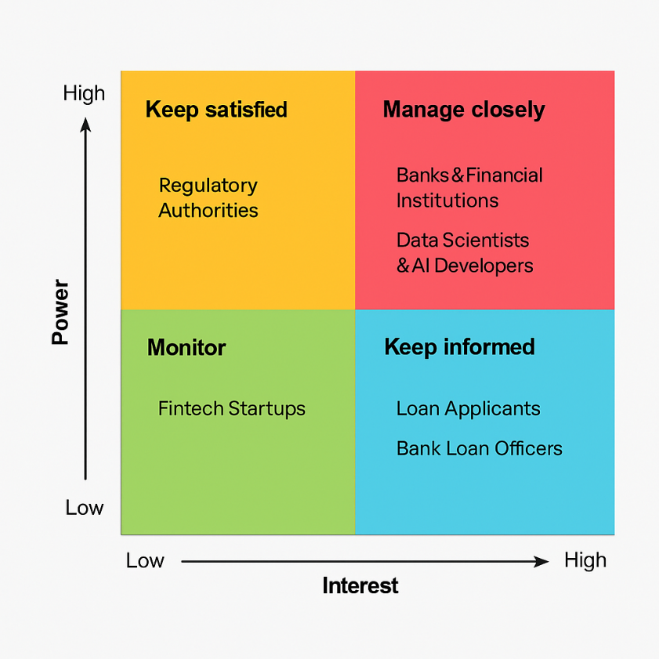

**High Power, High Interest:**

* Bank Managers & Loan Officers:Directly use the prediction system to assess applications. Their feedback and involvement are crucial for success.
* Financial Institutions (Banks, NBFCs):Will implement the solution and ensure it's aligned with their lending policies and customer service standards.

**High Power, Low Interest:**

* Loan Applicants (Customers):Directly impacted by the model’s decisions but have limited control over the system's implementation.

**Low Power, High Interest:**

* Credit Analysts & Financial Advisors:Interested in how AI changes creditworthiness assessments and risk modeling.

**Low Power, Low Interest:**

* AI Developers & Data Scientists:Build and fine-tune the prediction model. They influence performance but don’t set business rules.
* IT Support Teams:Maintain infrastructure but are not part of strategic decision-making.

**7.Empathetic Interviews**

**Conduct Skilled interview with at least 30 citizens/Users by asking open ended questions (What, why/How etc) and list the insights as per the format below**

|  |  |  |
| --- | --- | --- |
| **I need to know**  **(thoughts, feelings, actions)** | **Questions I will ask**  **(open questions)** | **Insights I hope to gain** |
| Thoughts | What do you know about how banks evaluate loan applications? | Awareness about existing loan approval processes |
|  | How do you think technology or AI can help in loan processing? | Perception of AI in financial services |
|  | What factors do you believe are most important in loan approval? | Public understanding of eligibility criteria |
| Feelings | How would you feel if an AI tool decided whether you’re eligible for a loan? | Trust and comfort level with automated  financial decisions |
|  | Why do you think some people fear being rejected by automated systems? | Concerns around fairness, bias, and transparency |
|  | How confident are you in the accuracy of AI tools for making such decisions? | Confidence in AI-based financial systems |
| actions | What do you do when you need to apply for a loan? | Steps and decision-making in loan applications |
|  | How do you usually check your loan eligibility? | Channels used for healthcare information |
|  | Have you ever faced loan rejection? If yes, what did you do next? | Common barriers and reactions to rejection |

**SKILLED INTERVIEW REPORT**

|  |  |  |
| --- | --- | --- |
| **User/Interviewee** | **Questions Asked** | **Insights gained (NOT THEIR ANSWERS)** |
| Ramesh S., Bank Manager | What challenges do banks face when evaluating loan applications manually? | Manual processes are time-consuming and prone to human error; there is a need for quicker and fairer evaluations. |
| Aarti D., Working Professional | How do you feel about AI being used to predict loan eligibility? | Curious but cautious concerned about transparency and fairness in decision-making. |
| Prakash M., Small Business Owner | Have you ever faced a loan rejection? What happened afterward? | Felt the process lacked clarity and was unsure how to improve eligibility in the future. |
| Sneha R., Homemaker | How do you usually apply for loans or check eligibility? | Often relies on family members or local agents due to lack of digital awareness. |
| Dev P., IT Engineer | What would make you trust an AI loan approval system? | Clear communication of how decisions are made and assurance of data privacy. |
| Kavitha T., College Graduate | Do you think AI-based systems can help first-time loan applicants? | Yes, if it provides guidance and alternative options when rejected. |
| Arvind B., Farmer | What challenges do rural citizens face while applying for loans? | Limited access to banking services and lack of digital infrastructure. |
| Meena J., Retired Teacher | How confident are you in your understanding of loan eligibility rules? | Eligibility rules are confusing and not easily accessible to older users. |
| Rizwan K., Auto Driver | Have you heard about AI in banking services? What do you think about it? | Heard of it but skeptical about how it affects common people and fairness. |

**Key Insights Gained:**

**Insight 1:** Manual loan application evaluations are time-consuming and inconsistent, often affected by human error or bias.

**Insight 2:** Many users are unaware of the exact eligibility criteria and face confusion or anxiety when rejected without explanation.

**Insight 3:** Trust in AI systems varies—tech-savvy users are more open to AI predictions, while others demand transparency and fairness.

**8.Empathy Map**

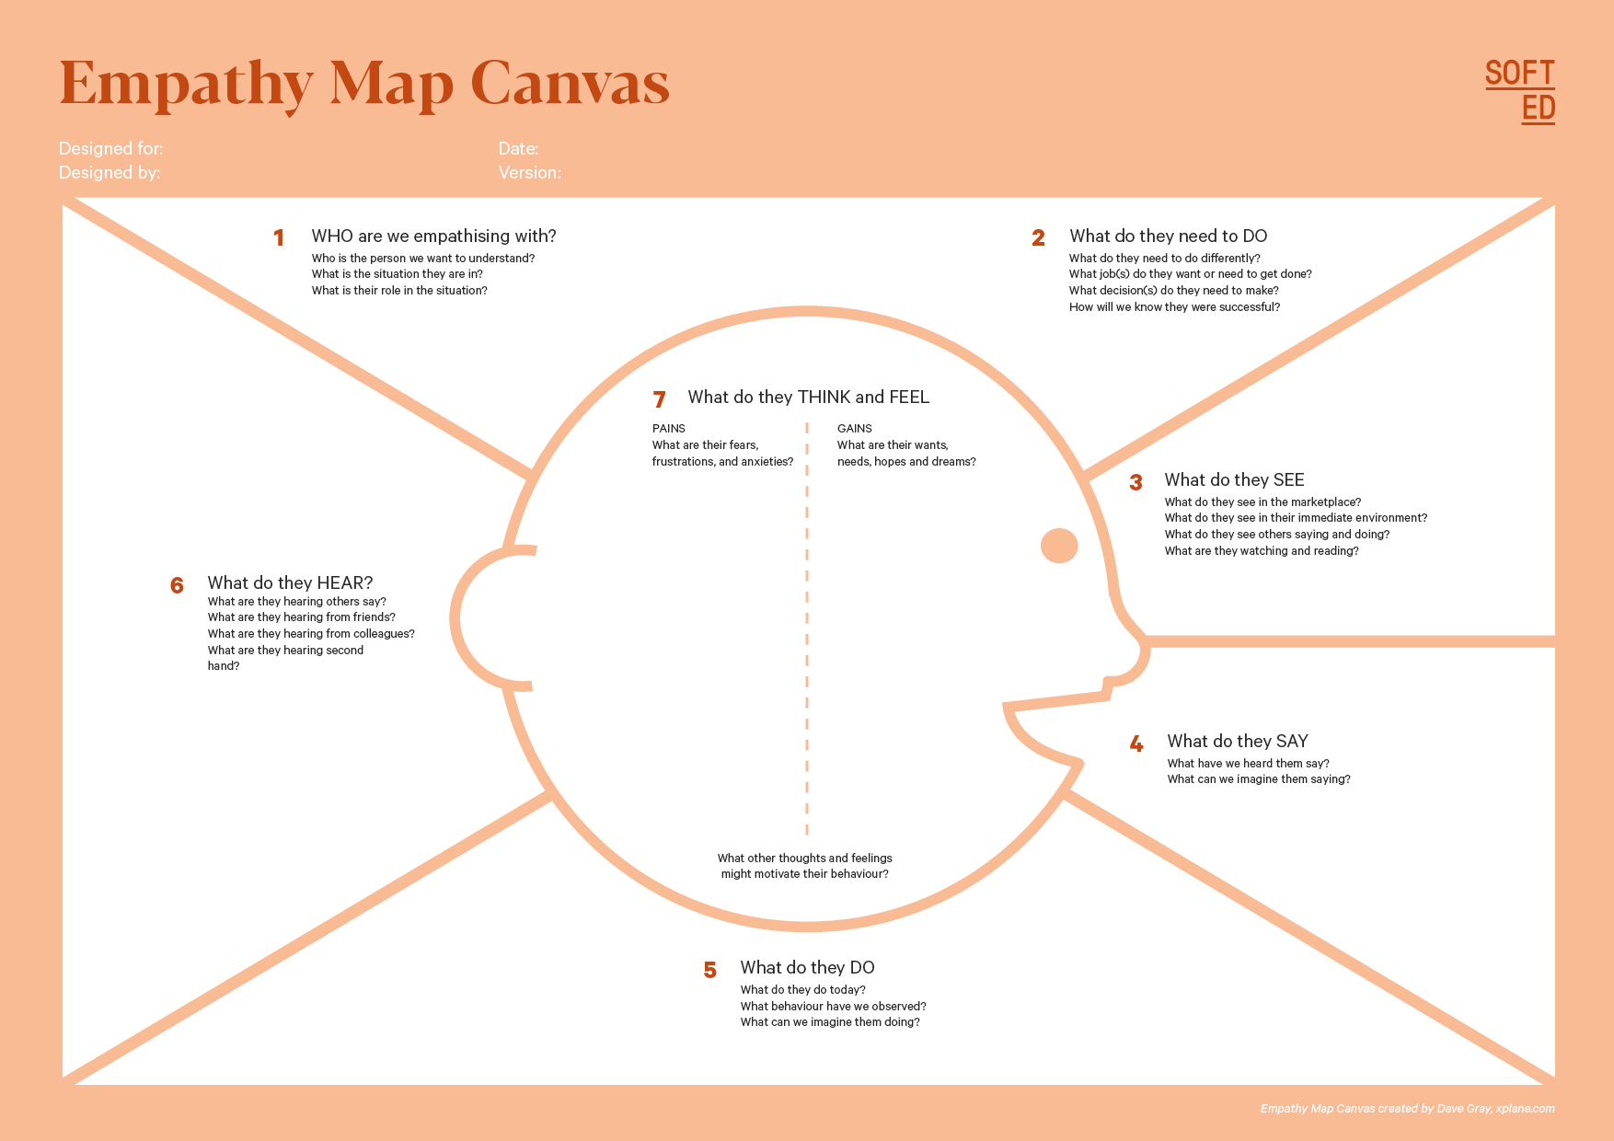

Your Answer: 1. From friends: “Try this bank, they approved my loan quickly.”

2. From media: “AI-based systems can simplify loan processing.”

Your Answer: 1. Individuals seeking loan approval.

2. Middle-income individuals with stable or semi- stable income.

Who is your Customer : People applying for personal or home loans through banks or online platforms

egment:

Idea/Innovation Title: AI-Based Loan Eligibility Prediction System

Designed By:K.Santhoshini

Date of Submission:17-04-2025

Your Answer: Loan rejection despite need.

Your Answer: Want fast, fair, and transparent loan evaluation.

Your Answer: Hopes for approval based on overall profile, not just credit score.

Your Answer: • Provide valid personal, financial, and employment details.

• Submit necessary documentation (income proof, ID, etc.).

Your Answer: • Banks with long processing times or rejections.

• Online lending platforms offering quick approvals.

Your Answer: “I need a loan, but I don’t know if I’m eligible.”

Your Answer: 1.Compare banks or NBFCs for easier loan approval.

2. Try using online eligibility calculators.

**9.Empathy Map**

1. **Who is your customer?**

Customer Profile:

* Age Group: 25–60 years old (loan applicants), 28–55 years (loan officers & financial analysts)
* Profession: Salaried employees, self-employed individuals, small business owners, bank staff, loan agents
* Interests: Financial independence, home/business ownership, credit management, access to fair banking services

Goals & Needs:

* Goal-Accurate and fair assessment of loan eligibility

Needs-

* Transparent and unbiased prediction system
* Quick pre-approval process to save time
* Simple interface for applicants and financial institutions
* Detailed risk reports and justifications for decisions

Context of Interaction:

* Applicants access the system via banking apps, websites, or at loan service centers
* Loan officers use predictions to assist in decision-making

1. **Who are we empathizing with?**

User Characteristics:

* Applicants- Hopeful, financially stressed, and sometimes unfamiliar with technical terms
* Loan Officers- Responsible, detail-oriented, cautious about false approvals/rejections
* Bank Management- Results-driven, looking for improved efficiency, yet wary of regulatory compliance

Values:

* Applicants- Financial security, fairness, quick processing
* Loan Officers- Reliable assessments, low default risk, trust in the system
* Bank Management- Risk mitigation, operational efficiency, customer satisfaction

Goals & Challenges:

* Make predictions accessible across urban and rural areas
* Provide fair eligibility prediction with minimal bias
* Ensure AI decisions are explainable and compliant with financial regulations

Challenges :

* Applicants fear rejection due to poor credit or system errors
* Loan officers worry about algorithmic bias and legal liabilities
* Management struggles with balancing automation and human oversight

1. **What do they need to DO?**

Tasks & Actions:

* Applicants- Submit financial documents, complete loan applications, monitor credit score
* Loan Officers- Review eligibility predictions, validate with paperwork, guide clients
* Bank Management- Analyze model outputs, monitor approval rates, improve processes

Decisions They Need to Make:

* When to apply for a loan
* Whether to trust AI based decisions
* How to explain loan denials or approvals
* Whether to Scale AI tools to more branches

1. **What do they SEE?**

Physical & Digital Environment:

* Applicants- Bank websites, loan calculators, approval emails
* Loan Officers- Internal dashboards, loan application forms
* Management- Data analytic tools, compliance reports, fintech trends

Trends & Competitors:

* Growth of AI in financial services
* Surge in automated credit risk scoring systems
* Competitor tools like Credit Karma or Experian decisioning platforms

How This Influences Them:

* Applicants feel anxious yet optimistic about digital approval systems
* Loan Officers compares features like interpretability and risk metrics
* Management values data-backed performance improvements

1. **What do they SAY?**

Public Statements & Feedback:

* Applicants- “I just want to know why I was approved or rejected.”
* Loan Officers- “This tool should make my work faster, not harder.”
* Management- “We need to reduce defaults while staying compliant.”

Frustrations Expressed:

* Applicants- “My loan was rejected without a clear reason.”
* Loan Officers- “The AI decision doesn’t explain the risk well enough.”
* Management- “We can't afford regulatory penalties from biased models.”

1. **What do they DO?**

Observable Actions & Habits:

* Applicants-
* Compare loan offers, use EMI calculators, improve credit scores
* Engage with customer service for clarity
* Loan Officers-
* Track approval/rejection rates, explore fintech partnerships

Problem-Solving Approaches:

* Applicants- Get co-applicants, improve financial behaviour
* Loan Officers- Use both AI and manual review for borderline case
* Management- Run pilot tests, assess impact of AI integration

1. **What do they HEAR?**

External Influences:

* Applicants- Friends with loan experiences, social media finance tips
* Loan Officers- Bank training sessions, fintech trends
* Management- Regulatory advisories, competitor performance

Channels of Information:

* Credit rating agencies, financial news portals
* Bank newsletters, AI implementation case studies
* Financial conference, peer banking network

Strong Influences on Behavior:

* Success stories encourage applicants to apply
* Compliance alerts drive process updates in banks
* Peer review affect adoption of AI among officers

1. **What do they THINK and FEEL?**

Fears & Worries:

* Applicants- “Will I ever qualify for a loan if this fails?”
* Loan Officers- “What if the tool wrongly approves a high-risk applicant?”
* Management- “Is the model auditable and transparent enough?”

Motivations & Desires:

* Applicants- Want access to credit and financial growth
* Loan Officers- Want fast, accurate evaluations with minimal disputes
* Management- Seek competitive edge and regulatory saftey

Internal Thoughts:

* Applicants- “I hope my application gets a fair chance.”
* Loan Officers- “This AI must back up its predictions with facts.”
* Management- “If this wok, it could revolutionize our loan system.”

1. **Pains and Gains**

Pains (Challenges & Frustrations):

* Lengthy loan processing time
* Rejections due to unclear credit criteria
* Trust gap between users and AI system

Gains (Desired Benefits):

* Instant, fair, and data-driven eligibility predictions
* Reduced workload for staff
* Improved loan approval experience for applicants
* Greater financial inclusion and trasnparency

**10.Persona of Stakeholders**

**Stakeholder Name:**

**Primary:** Loan Applicants (individual borrowers)

**Secondary:** Bank Staff (Loan Officers, Relationship Managers)

**Tertiary:** Financial Analysts & Credit Risk Teams (Policy Makers)

**Demographics:**

Loan Applicants-

* Age: 25–60 years
* Gender: All genders
* Income: Lower-middle to upper-middle income groups (salaried & self-employed)
* Location: Primarily urban and semi-urban, with growing access from rural areas via online portals
* Tech Literacy: Moderate to high (mobile and app users)

Bank Staff-

* Age: 28–55 years
* Gender: All genders
* Income: Middle to upper-middle class (financial professionals)
* Location: Urban branches, customer service centers, rural banking outlets
* Tech Literacy: High (use of banking software and dashboards)

Financial Analysts / Credit Risk Teams-

* Age: 30–60 years
* Gender: All genders
* Income: Upper-middle class (corporate-level staff)
* Location: Central office, HQ, data science teams
* Tech Literacy: Very high (work with analytics and AI tools)

**Goals:**

Loan Applicants-

* Get loans approved quickly with minimal paperwork
* Understand eligibility clearly without jargon
* Avoid rejections that affect credit score
* Receive fair assessments without bias
* Ensure privacy and security of their personal data

Bank Staff-

* Reduce processing time for loan applications
* Improve customer experience with faster decisions
* Meet monthly/quarterly disbursal targets efficiently
* Minimize manual errors and misjudgments

Credit Risk Teams-

* Use AI to flag risky applications early
* Maintain balanced loan approval ratios
* Enhance prediction accuracy to reduce non-performing assets (NPAs)
* Improve compliance with financial regulations

**Challenges:**

Applicants-

* Lack of credit knowledge and how eligibility is determined
* Confusion around required documents and procedures
* Fear of rejection and poor credit score impact
* Long approval times or lack of transparency

Bank Staff-

* High workload and repetitive eligibility checks
* Pressure to meet approval quotas while maintaining accuracy
* Lack of intuitive tools to support real-time decisions

Credit Analysts-

* Difficulty in analyzing unstructured or incomplete data
* Risk of bias or model inaccuracy affecting customer trust
* Explaining AI-based decisions to regulators and stakeholders

**Aspirations:**

Applicants-

* Be financially independent and creditworthy
* Access loans quickly for education, housing, or business
* Get empowered with clear eligibility insights
* Use mobile-friendly tools to simplify the loan journey

Bank Staff-

* Become more efficient and accurate in approvals
* Gain confidence in recommending eligible applicants
* Build better relationships with customers using technology

Risk Teams-

* Lead innovation with AI-based risk models
* Improve overall loan approval quality and reduce defaults
* Promote transparency and fairness through explainable AI

**Needs:**

Applicants-

* Easy-to-use eligibility check tools (mobile/web)
* Clear explanations of results and next steps
* Instant feedback and suggestions to improve eligibility

Bank Staff-

* AI-powered dashboards that auto-evaluate applicant data
* Integration with existing banking software
* Alerts for borderline or suspicious applications

Risk Teams-

* Validated and explainable AI models
* Visual analytics and performance metrics
* Continuous learning systems for improving model accuracy

**Pain Points:**

* Time-consuming manual screening process
* Rejected applications due to incomplete information
* Loan officers overwhelmed by volume and complexity
* Risk of bias or inconsistent approvals
* Customers frustrated with lack of clarity and long wait times

**Storytelling:**

Meet Ramesh, a 35-year-old small business owner from a semi-urban town. He wants to expand his local grocery store and needs a personal loan of ₹3 lakhs. But Ramesh is unsure about his credit score, eligibility, and what documents the bank needs.His friend tells him about FinCheck AI, a loan eligibility prediction tool offered through the bank’s app. Ramesh uploads his income proof, ID, and bank statements. In just a few minutes, he receives a clear score and suggestions to improve his eligibility — like submitting a utility bill to verify address and reducing his credit card usage.When he walks into the branch, the loan officer already has his pre-evaluated application and supports him through the final steps. The result? A fast, smooth approval. The bank officer saves time, and Ramesh grows his business without stress.

For Ramesh, it wasn’t just a score — it was the key to his future success.

**11. Look for Common Themes, Behaviors, Needs, and Pain Points among the Users**

Analyse the data from your affinity diagram to uncover recurring patterns among your users, helping you better understand their expectations and challenges.

**Common Themes:**

These are recurring ideas and issues that came up across patients, caregivers, and doctors in your research.

1. Uncertainty About Eligibility – Applicants are often unsure whether they qualify for a loan, leading to anxiety and hesitation..
2. Trust in Technology – Users are cautiously optimistic but want transparency and fairness in automated decisions..
3. Desire for Quick Results-Everyone wants fast, real-time eligibility results without long waits or excessive paperwork.
4. Lack of Financial Literacy – Many users don’t fully understand credit scores, interest rates, or the criteria banks use to evaluate them.
5. Emotional and Financial Burden – Applicants worry about the consequences of being rejected and how it might affect future applications.
6. Need for Human Touch – Despite automation, users still value having access to a real person to answer questions or appeal decisions.

**Common Behaviors:**

These are observed actions and habits shared across loan applicants and stakeholder

1. Pre-Check Online Calculators – Users often use online tools or bank websites to estimate loan eligibility before applying.
2. Document Overload - Applicants struggle to gather the correct documents and often miss out on key requirements.
3. Multiple Loan Applications – Users tend to apply to different banks or financial platforms to maximize chances..
4. Search for peer Review and Experiences – People look at forums, social media, and YouTube to learn about others’ loan approval stories.
5. Data Guessing and Trial-and-Error – Users often experiment with different inputs on online forms to see what “works” for approval.

**Common Needs:**

These are essential requirements or desires across all stakeholders involved in the loan application process.

1. Accurate Eligibility Prediction– Applicants want a system that reliably forecasts approval chances based on their real financial data.
2. Simple, Non-Technical Language– Users need easy-to-understand outcomes and explanations without jargon.
3. Real-Time Feedback– Stakeholders want immediate suggestions to improve eligibility (e.g., credit score, income threshold).
4. Explainable AI – Users, especially loan officers, require transparency into why someone was approved or denied.
5. Secure Data Handling – Users need assurance that sensitive data (salary, bank records) is protected and not misused.

**Common Pain Points:**

These are recurring frustrations and barriers experienced by users and stakeholders in the loan approval process..

1. Ambiguous Rejection Reasons – Users often receive vague rejection messages without clear feedback.
2. Bias Concerns – Applicants fear that AI may reinforce biases based on location, gender, or employment type.
3. Time-Consuming Process – The loan application journey often involves repeated steps, waiting, and unnecessary delays.
4. Low Trust in Digital Systems – Some users are skeptical of online tools and prefer physical consultations.
5. Inconsistent Evaluation Standards – Different banks or platforms use varying criteria, creating confusion.
6. Overwhelming Information– Users feel lost due to conflicting advice from websites, banks, and financial advisors.

**12. Define Needs and Insights of Your Users**

**User Needs:**

|  |  |
| --- | --- |
| **Category** | **User Needs** |
| **Functional Needs** | * A user-friendly tool to check loan eligibility before applying.. * Instant, accurate predictions without manual form-filling or paperwork. * Clear, understandable results with suggestions to improve chances (e.g., credit score, income) * Integration with bank systems to streamline the approval process. * Data security and privacy during financial data analysis. |
| **Emotional Needs** | * Confidence and clarity before applying for a loan. * Reassurance that they’re not being unfairly judged or rejected. * Trust in the AI tool's fairness and transparency. * Reduced stress from uncertainty about eligibility or fear of rejection. |
| **Societal Needs** | * Greater access to financial services for underserved users (e.g., freelancers, low-income groups, rural applicants) * Increased financial literacy through educational suggestions embedded in the tool. * Encouragement for responsible borrowing and better financial planning. |

|  |  |
| --- | --- |
| **Theme** | **User Insights** |
| **Eligibility Anxiety** | Applicants often feel anxious due to a lack of understanding about loan criteria and fear of rejection. They need clarity before applying.. |
| **Trust in AI** | Users are open to automated predictions but need transparency—explanations, examples, and certifications to trust AI-based decisions |
| **Decision Support** | Many users (especially first-time applicants) rely on family or financial advisors for decisions; tools should support shared decision-making.. |
| **Information Confusion** | Users often receive mixed advice from banks, forums, and peers. They struggle to know what truly improves eligibility. |
| **Emotional Farming** | Applicants are sensitive to rejection; harsh or vague outcomes can discourage them from trying again. Positive, constructive feedback is critical. |
| **Need for Simplicity** | Users prefer visual cues like traffic-light indicators (green = eligible, yellow = borderline, red = not eligible) to interpret results quickly |
| **Affordability Factor** | High consultation or broker fees deter users. A free or low-cost eligibility checker makes financial advice more inclusive. |
| **Bank Officer Need**  **Involvement** | Bankers are willing to use AI tools if the results are explainable, legally compliant, and integrated smoothly into their existing workflow. |

**User Insights:**

**13. POV Statements**

**POV Statements:**

|  |  |  |  |
| --- | --- | --- | --- |
| **POV Statements** | **Role-based or**  **Situation-**  **Based** | **Benefit, Way to**  **Benefit, Job TBD,**  **Need (more/less)** | **PoV Questions** |
| 1. A first-time loan applicant needs a way to understand if they’re eligible before applying because they’re unfamiliar with loan criteria. | Role-based  (Time Applicant) | More clarity and confidence before applying | How might we design a tool that explains eligibility simply to first-time applicants? |
| 2. A gig worker with irregular income needs a way to get fair eligibility assessment because traditional salary slips don’t represent their real earnings. | Role-based (gig worker) | More inclusive financial assessment | How might we create a system that evaluates non-traditional income fairly for loan decisions? |
| 3. A busy professional needs a way to check loan eligibility quickly because they don’t have time for long application processes | Situation-based (busy lifestyle) | Faster pre-checks and application process | What can we design to make loan eligibility checks fast and seamless? |
| 4. A bank officer needs a way to validate AI predictions because they must ensure the decision complies with policy and regulation. | Role-based (bank staff) | More trustworthy and explainable results | How can we design an AI system that bank officers can audit and rely on? |
| 5. A low-income applicant needs a way to explore small loan options because they often get rejected by mainstream lenders. | Situation-based (Low-income applicant) | More accessible and flexible loan options | How can we offer personalized, small-scale loan suggestions based on real need? |
| 6. A student needs a way to check education loan eligibility without a co-signer because they are financially independent.. | Role-based (student) | More autonomy and opportunity | How can we design eligibility checks that don’t always require guarantors for students? |
| 7. A financially anxious user needs a way to receive results without stress because rejection messages can be discouraging.. | Role-based (anxious personality) | More accessible interface | How might we design a simplified, multilingual tool for users in rural areas? |
| 8 A rural applicant with limited digital literacy needs a simple way to check loan eligibility because complex forms and jargon are barriers. | Role-based  (rural/digitally limited user) | More affordable early detection | How might we design a user experience that gives results in a supportive and constructive tone? |
| 9. A tech-savvy applicant needs a way to understand how the AI decision was made because they want control and transparency. | Role-based (tech-savvy user) | More visibility into the AI logic | How can we provide explainable AI feedback that tech users can understand and trust? |
| 10. A loan aggregator or financial advisor needs a way to pre-screen multiple clients efficiently because they handle high application volumes. | Role-based (loan aggregator/advisor) | More scalable screening process | How might we design a tool that allows bulk eligibility checks and client management? |

**14. Develop POV/How Might We (HMW) Questions to Transform Insights/Needs into Opportunities for Design**

|  |  |
| --- | --- |
| **User Need/Insight** | **"How Might We" Question** |
| Many applicants, especially in rural areas, lack access to loan advisory services and don’t know if they’re eligible. | How might we create an affordable and accessible loan eligibility tool for users in remote and underserved areas? |
| First-time or low-literacy applicants struggle to understand complex loan terms and eligibility criteria. | How might we simplify loan eligibility criteria and explain them in a way that’s easy for anyone to understand? |
| Gig workers and freelancers are often denied loans due to non-traditional income structures. | How might we design a more inclusive AI model that fairly evaluates gig workers and freelancers? |
| Users often feel nervous or discouraged when receiving rejection messages from loan applications. | How might we create a user-friendly, empathetic interface that delivers results without discouraging users? |
| Financially anxious users fear credit rejection and avoid applying for loans even when they qualify. | How might we encourage hesitant users to try the eligibility checker by making the process low-risk and non-judgmental? |

Turn your user needs and insights into actionable opportunities by framing them as "How Might We" (HMW) questions. These questions will spark creative problem-solving and guide

**15. Crafting a Balanced and Actionable Design Challenge**

The Design Challenge Should Neither Be Too Narrow Nor Too Broad and It Should Be an Actionable Statement with a quantifiable goal. It should be a culmination of the POV questions developed.

**Design Challenge:** How might we design an inclusive, user-friendly, and transparent AI-based loan eligibility prediction tool that empowers diverse users—especially those in underserved and non-traditional employment sectors—to assess their eligibility quickly, understand the decision-making clearly, and improve access to credit, with a goal of increasing approved applications by at least 25% in the next 18 months?

**16. Validating the Problem Statement with Stakeholders for Alignment**

Ensure your problem statement accurately represents the needs and concerns of your stakeholders and users. This involves gathering feedback from these groups to confirm that the problem is relevant and significant from their perspective. By validating early, you can refine the problem statement to better align with real-world challenges, ensuring your solution addresses the correct issues.

**Validation Plan:**

|  |  |  |  |
| --- | --- | --- | --- |
| Stakeholder/User | Role/Title | Feedback on Problem Statement | Suggestions for  Improvement |
| Mr. Anil Deshmukh | Bank Loan Officer | The problem is significant — manual eligibility checks are time-consuming and prone to bias. | Include risk-level categorization for applicants to help loan officers make better decisions. |
| Priya Rathi | Loan Applicant (Rejected) | Very relevant — feels existing systems are opaque and confusing. | Make sure the tool gives clear reasons for eligibility or rejection. |
| Sunil Mehra | Financial Advisor | Agrees with the relevance — clients often don't know what qualifies them. | Add an eligibility simulator or pre-check tool for better customer education. |
| Dr. Meenal Kapoor | AI and FinTech Researcher | Relevant in modern banking. Real-time eligibility checks can streamline lending. | Include explainable AI so applicants and banks understand the decision logic. |
| Rajesh Jadhav | Startup Founder (Fintech) | Matches current fintech goals — automation and inclusivity in lending. | Integrate with digital KYC and existing banking APIs for seamless processing. |
| Nikita Sharma | Credit Risk Analyst | Strong alignment — helps reduce default rates by better screening. | Add a feedback loop to improve the model based on repayment behavior. |
| Mohammed Irfan | Rural Bank Branch Manager | Problem is highly relevant, especially in underserved areas. | Ensure it works offline or with low-bandwidth networks; include support for regional languages. |
| Rekha Sinha | Legal Advisor | Useful, but ensure the tool complies with financial regulations (RBI, etc.). | Add audit logs and consent-based data usage for compliance. |
| Loan Eligibility Forum | Financial Literacy NGO | Supports tools that promote transparency in loan approvals. | Highlight financial literacy features and provide explanations in simple language. |
| Dr. Ravi Kulkarni | Economist | Important problem — loan access drives economic growth. | Consider emphasizing inclusion of informal sector and gig economy workers in eligibility. |

**17. Ideation**

**Ideation Process:**

|  |  |  |  |
| --- | --- | --- | --- |
| Idea No | Proposed Solution | Key Features/Benefits | Challenges/Concerns |
| Idea 1 | AI-powered Loan Eligibility Web App | * Collects user input on income, employment, credit history * Instantly predicts eligibility with a probability score * Provides reasons for approval/rejection using explainable AI | * Ensuring fairness and non-bias in prediction * Requires secure handling of sensitive financial data |
| Idea 2 | Mobile App with Real-time Pre-Eligibility Check | * Allows users to check their eligibility before applying * Uses minimal inputs (PAN, salary, EMI) * Suggests tips to improve chances | * Users may provide incorrect/incomplete data * Needs constant model updates based on policy changes |
| Idea 3 | Loan Officer Dashboard with AI Suggestions | * Helps officers compare applicants with predicted risk scores * Highlights high-risk applications * Reduces human error in manual screening | * Requires strong NLP engine for financial context * Speech-to-text accuracy varies with language/accent |
| Idea 4 | Eligibility Tool for Informal Sector Workers | * Special module to assess non-salaried individuals * Uses alternative data (mobile bill, rent payments) * Promotes financial inclusion | * Lack of reliable financial history * Risk of inaccurate predictions in edge cases |
| Idea 5 | Voice-based Loan Inquiry Chatbot | * Users can ask loan-related questions via voice * AI analyses voice for early signs Collects basic info and runs pre-checks * Multilingual support for accessibility | * Requires strong NLP engine for financial context * Speech-to-text accuracy varies with language/accent |

**18. Idea Evaluation**

Evaluate the Idea based on 10/100/1000 grams

|  |  |  |  |  |
| --- | --- | --- | --- | --- |
| Idea | Impact (10/100/1000 grams) | Feasibility (10/100/1000 grams) | Alignment (10/100/1000 grams) | Total Weight |
| Idea 1 | **1000** | **1000** | **1000** | **3000** |
| Idea 2 | **1000** | **100** | **1000** | **2100** |
| Idea 3 | **100** | **1000** | **1000** | **2100** |
| Idea 4 | **1000** | **100** | **1000** | **2100** |
| Idea 5 | **100** | **100** | **1000** | **2100** |

**Explanation:**

* **Impact**: How much the solution can improve access to loans, decision transparency, and financial inclusion.
* **Feasibility**: How practical it is to develop and implement the idea using current technologies and datasets.
* **Alignment**: How well the idea addresses the needs of stakeholders (applicants, banks, regulators) and the core design challenge.

**Key Observations:**

* **Idea 1** scores the highest across all parameters, offering high usability, transparency, and technical feasibility.
* **Idea 2** and **Idea 5** are impactful and aligned with user needs (especially for early checks and inclusion) but may face feasibility issues due to limited data and user errors.
* **Idea 3** is highly feasible and aligns well with institutional needs (loan officers) but has slightly lower user-facing impact.
* **Idea 4** (voice chatbot) scores lower overall due to current limitations in NLP accuracy for multilingual and financial-specific queries.

**Solution Concept Form**

**1. Problem Statement:**

* Many loan applicants face rejections due to unclear eligibility criteria, lack of transparency, and delays in the manual verification process. This leads to frustration and reduced trust in financial institutions.

**2. Target Audience:**

* Individuals seeking personal or home loans, especially salaried employees, small business owners, freelancers, and first-time borrowers who want to understand their loan eligibility before applying.

**3. Solution Overview:**

* The solution is an AI-powered Loan Eligibility Prediction System that analyzes applicant data such as income, employment, credit history, and other relevant factors to instantly determine the likelihood of loan approval. It offers a faster, data-driven, and transparent eligibility evaluation process.

**4. Key Features:**

| **Feature** | **Description** |
| --- | --- |
| **Feature 1** | **Real-time Loan Eligibility Check** – Instantly evaluates loan eligibility using machine learning algorithms. |
| **Feature 2** | **User-friendly Web Interface** – Simple input forms for applicants to enter their financial and personal details. |
| **Feature 3** | **Personalized Suggestions** – Provides tailored recommendations for improving eligibility based on prediction results. |

**5. Benefits:**

| **Benefit** | **Description** |
| --- | --- |
| **Benefit 1** | **Faster Decision-making** – Reduces waiting time by instantly predicting eligibility |
| **Benefit 2** | **Improved Transparency** – Clarifies why an applicant qualifies or does not qualify. |
| **Benefit 3** | **Increased Approval Rate** – Helps users take corrective actions before applying officially, improving their chances. |

**6. Unique Value Proposition (UVP):**

* This AI-based tool offers a quick, smart, and personalized way for applicants to assess their loan eligibility, eliminating guesswork and reducing chances of rejection — all from the comfort of their home.

**7. Key Metrics:**

| **Metric** | **Measurement** |
| --- | --- |
| **Metric 1** | Number of users checking eligibility per month. |
| **Metric 2** | Conversion rate from eligibility check to successful loan applications. |

**8. Feasibility Assessment:**

* The solution is highly feasible with current technology. With access to open-source ML libraries, secure data handling platforms, and sufficient time (approx. 3–6 months), a prototype can be built and integrated with financial institutions or loan marketplaces.

**9. Next Steps:**

* ✔ Gather a sample dataset for model training
* ✔ Build and test the machine learning model
* ✔ Design the user interface (UI/UX)
* ✔ Integrate model with the UI
* ✔ Conduct pilot testing with real users
* ✔ Gather feedback and improve the system